SpringBoot Assignment (10.07.2026)

Spring Boot Assignment
Assignment 1: Student Management System using Spring Boot Layers
Objective
Create a Spring Boot application that demonstrates the use of Controller, Service, and Repository
layers.
Requirements
1.Create a Student class with:
- id
- name
- email
- course
2.Create the following layers:
- StudentController
- StudentService
- StudentRepository
3.Use Spring Boot annotations:
- @SpringBootApplication
- @Controller or @RestController
- @Service
- @Repository
- @Autowired
4.Implement methods to:
- Add a Student
- View All Students
- Find Student by ID
5.Store student data in a collection (ArrayList) instead of a database.
6.Test the application using a browser or Postman.

Deliverables
- Source Code
- Project Structure Screenshot
- Output Screenshot
- Explanation of each layer's responsibility

Solution:
Project Structure

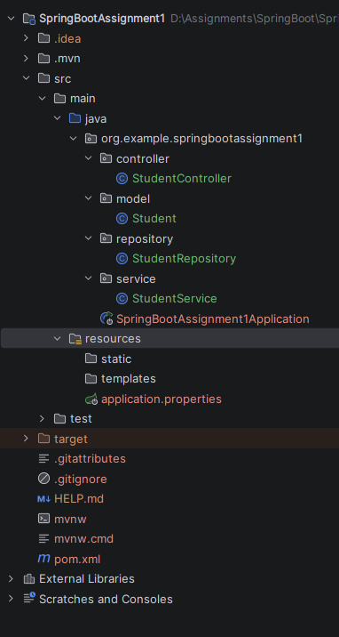

pom.xml
<?xml version="1.0" encoding="UTF-8"?>
<project xmlns="http://maven.apache.org/POM/4.0.0" xmlns:xsi="http://www.w3.org/2001/XMLSchema-instance"
xsi:schemaLocation="http://maven.apache.org/POM/4.0.0 https://maven.apache.org/xsd/maven-4.0.0.xsd">
<modelVersion>4.0.0</modelVersion>
<parent>
<groupId>org.springframework.boot</groupId>
<artifactId>spring-boot-starter-parent</artifactId>
<version>4.1.0</version>
<relativePath/> <!-- lookup parent from repository -->
</parent>
<groupId>org.example</groupId>
<artifactId>SpringBootAssignment1</artifactId>
<version>0.0.1-SNAPSHOT</version>
<name>SpringBootAssignment1</name>
<description>SpringBootAssignment1</description>
<url/>
<licenses>
<license/>
</licenses>
<developers>
<developer/>
</developers>
<scm>
<connection/>
<developerConnection/>
<tag/>
<url/>
</scm>
<properties>
<java.version>21</java.version>
</properties>
<dependencies>
<dependency>
<groupId>org.springframework.boot</groupId>
<artifactId>spring-boot-starter-webmvc</artifactId>
</dependency>
<dependency>
<groupId>org.springframework.boot</groupId>
<artifactId>spring-boot-starter-webmvc-test</artifactId>
<scope>test</scope>
</dependency>
</dependencies>
<build>
<plugins>
<plugin>
<groupId>org.springframework.boot</groupId>
<artifactId>spring-boot-maven-plugin</artifactId>
</plugin>
</plugins>
</build>
</project>

model/Student.java
package org.example.springbootassignment1.model;
public class Student {
private int id;
private String name;
private String dept;
public Student(){}
public Student(int id, String name, String dept) {
this.id = id;
this.name = name;
this.dept = dept;
}
public int getId() {
return id;
}
public void setId(int id) {
this.id = id;
}
public String getName() {
return name;
}
public void setName(String name) {
this.name = name;
}
public String getDept() {
return dept;
}
public void setDept(String dept) {
this.dept = dept;
}
}

repository/StudentRepository.java
package org.example.springbootassignment1.repository;
import org.springframework.stereotype.Repository;
import org.example.springbootassignment1.model.Student;
import java.util.List;
import java.util.ArrayList;
@Repository
public class StudentRepository {
private List<Student> stud = new ArrayList<>();
public void saveStudent(Student student){
stud.add(student);
}
public List<Student> getStudent(){
return stud;
}
public Student getByStudId(int id){
for(Student std:stud){
if(std.getId() == id){
return std;
}
}
return null;
}
}
service/StudentService.java
package org.example.springbootassignment1.service;
import org.springframework.stereotype.Service;
import org.example.springbootassignment1.repository.StudentRepository;
import org.example.springbootassignment1.model.Student;
import java.util.List;
@Service
public class StudentService {
StudentRepository studRepo;
public StudentService(StudentRepository studRepo) {
this.studRepo = studRepo;
}
public void addStudent(Student student){
studRepo.saveStudent(student);
}
public List<Student> getAllStudent(){
return studRepo.getStudent();
}
public Student getById(int id){
return studRepo.getByStudId(id);
}
}

controller/StudentController.java
package org.example.springbootassignment1.controller;
import org.springframework.web.bind.annotation.*;
import org.example.springbootassignment1.service.StudentService;
import org.example.springbootassignment1.model.Student;
import java.util.List;
@RestController
@RequestMapping("/student")
public class StudentController {
StudentService studServ;
public StudentController(StudentService studServ) {
this.studServ = studServ;
}
@PostMapping("/add")
public String addStudent(@RequestBody Student student){
studServ.addStudent(student);
return "Student Insert Successfully";
}
// Url path: /?id=102
@GetMapping("/")
public Student getById(@RequestParam int id){
return studServ.getById(id);
}
// Url path: /102
@GetMapping("/{id}")
public Student getById2(@PathVariable int id) {
return studServ.getById(id);
}
@GetMapping("/get")
public List<Student> fetctAll(){
return studServ.getAllStudent();
}
}

MainApp.java
package org.example.springbootassignment1;
import org.springframework.boot.SpringApplication;
import org.springframework.boot.autoconfigure.SpringBootApplication;
@SpringBootApplication
public class MainApp {
public static void main(String[] args) {
SpringApplication.run(MainApp.class, args);
}
}

Output:

Student adding
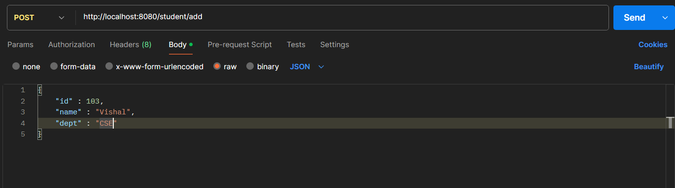

Fetch All Student
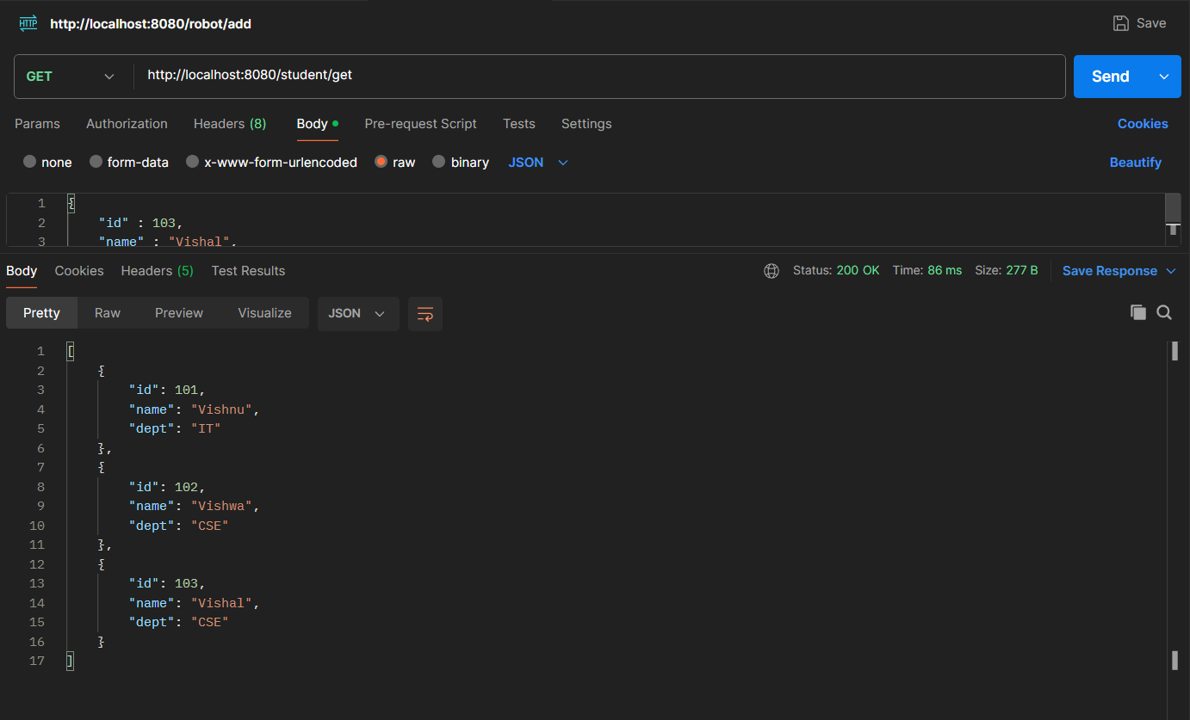

Fetch by Id Uniq Student
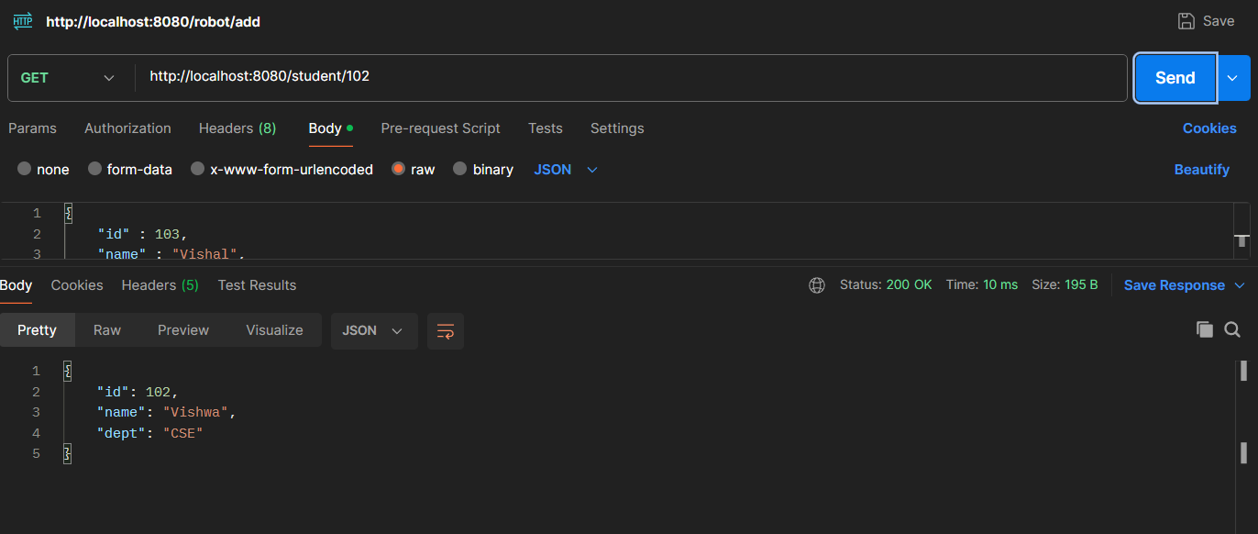

Explanation of each layer's responsibility

Layers:
- Model
- Controller
- Service
- Repository

Model:
Model layer manages student object and used for value set and get then using encapsulation the purpose of securing the data.

Controller:
Controller layer manages the request and response from the fronted or browser URL how to navigate with data.

Service:
Service layer manages the functionalities how to perform the data all the logics build in the service layer.

Repository:
Repository is the manage different databases and database operations like save, update, delete etc.

Assignment 2: Employee Management System using Spring Boot

Objective
Develop an Employee Management application to understand layered architecture.
Requirements
- Create an Employee class with:
  - empId
  - empName
  - department
  - salary
- Create:
  - EmployeeController
  - EmployeeService
  - EmployeeRepository
- Implement the following operations:
  - Add Employee
  - Get All Employees
  - Search Employee by ID
  - Delete Employee
- Use Spring Boot annotations appropriately.
- Demonstrate Dependency Injection using @Autowired.
- Explain the flow of a request:
  - Client → Controller → Service → Repository → Service → Controller → Client
Deliverables
- Complete Spring Boot Project
- Class Diagram
- Output Screenshots
- Short report explaining:
  - Spring Boot advantages
  - Layered Architecture
  - Use of Annotations (@Service, @Repository, @Autowired)
Solution:
project structure:
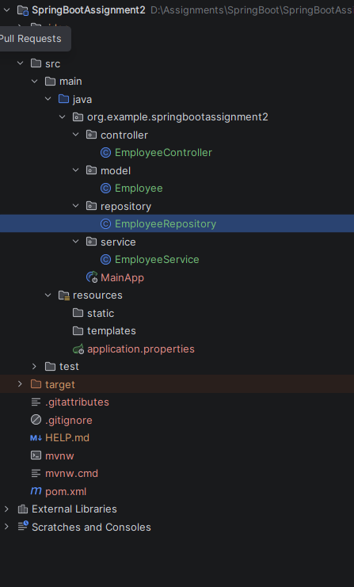

pom.xml
<?xml version="1.0" encoding="UTF-8"?>
<project xmlns="http://maven.apache.org/POM/4.0.0" xmlns:xsi="http://www.w3.org/2001/XMLSchema-instance"
xsi:schemaLocation="http://maven.apache.org/POM/4.0.0 https://maven.apache.org/xsd/maven-4.0.0.xsd">
<modelVersion>4.0.0</modelVersion>
<parent>
<groupId>org.springframework.boot</groupId>
<artifactId>spring-boot-starter-parent</artifactId>
<version>4.1.0</version>
<relativePath/> <!-- lookup parent from repository -->
</parent>
<groupId>org.example</groupId>
<artifactId>SpringBootAssignment2</artifactId>
<version>0.0.1-SNAPSHOT</version>
<name>SpringBootAssignment2</name>
<description>SpringBootAssignment2</description>
<url/>
<licenses>
<license/>
</licenses>
<developers>
<developer/>
</developers>
<scm>
<connection/>
<developerConnection/>
<tag/>
<url/>
</scm>
<properties>
<java.version>21</java.version>
</properties>
<dependencies>
<dependency>
<groupId>org.springframework.boot</groupId>
<artifactId>spring-boot-starter-webmvc</artifactId>
</dependency>
<dependency>
<groupId>org.springframework.boot</groupId>
<artifactId>spring-boot-starter-webmvc-test</artifactId>
<scope>test</scope>
</dependency>
</dependencies>
<build>
<plugins>
<plugin>
<groupId>org.springframework.boot</groupId>
<artifactId>spring-boot-maven-plugin</artifactId>
</plugin>
</plugins>
</build>
</project>

model/Employee.java
package org.example.springbootassignment2.model;
public class Employee {
private int empId;
private String empName;
private String department;
private double salary;
public Employee(int empId, String empName, String department, double salary) {
this.empId = empId;
this.empName = empName;
this.department = department;
this.salary = salary;
}
public int getEmpId() {
return empId;
}
public void setEmpId(int empId) {
this.empId = empId;
}
public String getEmpName() {
return empName;
}
public void setEmpName(String empName) {
this.empName = empName;
}
public String getDepartment() {
return department;
}
public void setDepartment(String department) {
this.department = department;
}
public double getSalary() {
return salary;
}
public void setSalary(double salary) {
this.salary = salary;
}
}

repository/EmployeeRepository.java
package org.example.springbootassignment2.repository;
import org.example.springbootassignment2.model.Employee;
import org.springframework.stereotype.Repository;
import java.util.List;
import java.util.ArrayList;
@Repository
public class EmployeeRepository {
List<Employee> emp = new ArrayList<>();
public void saveEmployee(Employee employee){
emp.add(employee);
}
public List<Employee> getAllEmployee(){
return emp;
}
public Employee searchById(int id){
for(Employee em: emp){
if(em.getEmpId() == id){
return em;
}
}
return null;
}
// public void deleteById(int id){
// emp.removeIf(em -> em.getEmpId() == id);
// }
public boolean deleteEmployeeById(int id) {
for (Employee em : emp) {
if (em.getEmpId() == id) {
emp.remove(em);
return true;
}
}
return false;
}
}

service/EmployeeService.java
package org.example.springbootassignment2.service;
import org.springframework.beans.factory.annotation.Autowired;
import org.example.springbootassignment2.repository.EmployeeRepository;
import org.example.springbootassignment2.model.Employee;
import org.springframework.stereotype.Service;
import java.util.List;
@Service
public class EmployeeService {
@Autowired
EmployeeRepository empRepo;
public void addEmployee(Employee employee){
empRepo.saveEmployee(employee);
}
public List<Employee> fetchAllEmployee(){
return empRepo.getAllEmployee();
}
public Employee searchById(int id){
return empRepo.searchById(id);
}
public boolean deleteById(int id){
return empRepo.deleteEmployeeById(id);
}
}

controller/EmployeeController.java
package org.example.springbootassignment2.controller;
import org.springframework.beans.factory.annotation.Autowired;
import org.springframework.web.bind.annotation.RestController;
import org.springframework.web.bind.annotation.RequestMapping;
import org.springframework.web.bind.annotation.RequestBody;
import org.springframework.web.bind.annotation.PostMapping;
import org.springframework.web.bind.annotation.GetMapping;
import org.springframework.web.bind.annotation.DeleteMapping;
import org.springframework.web.bind.annotation.PathVariable;
import org.example.springbootassignment2.service.EmployeeService;
import org.example.springbootassignment2.model.Employee;
import java.util.List;
@RestController
@RequestMapping("/employee")
public class EmployeeController {
@Autowired
EmployeeService empService;
@PostMapping("/add")
public String addEmployee(@RequestBody Employee employee){
empService.addEmployee(employee);
return "Employee successfully inserted";
}
@GetMapping("/getall")
public List<Employee> fetchAllEmployees(){
return empService.fetchAllEmployee();
}
@GetMapping("/{id}")
public Employee searchById(@PathVariable int id){
return empService.searchById(id);
}
@DeleteMapping("/{id}")
public String deleteById(@PathVariable int id){
return empService.deleteById(id)?"Employee Delete successfully":"Employee not Fount!";
}
}

Output:

Insert employees using POST method
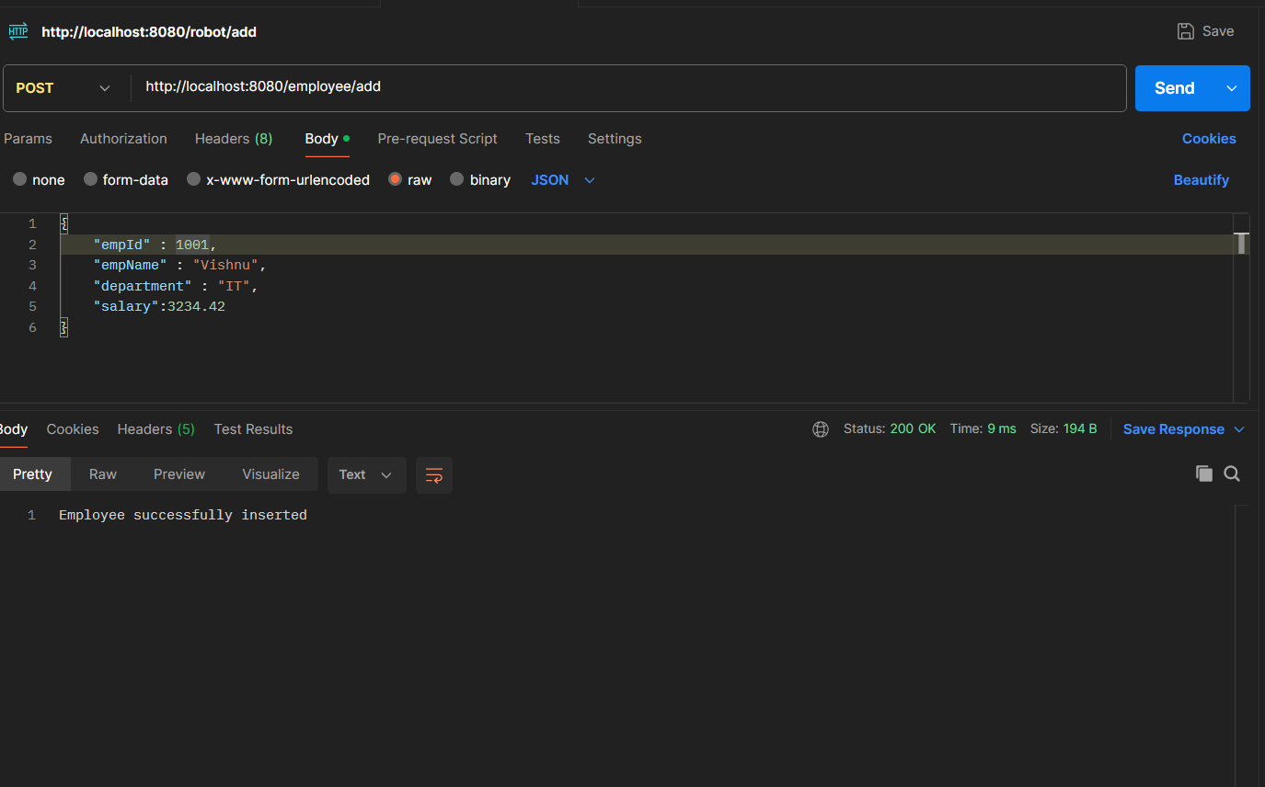
Fetch all employees using GET method
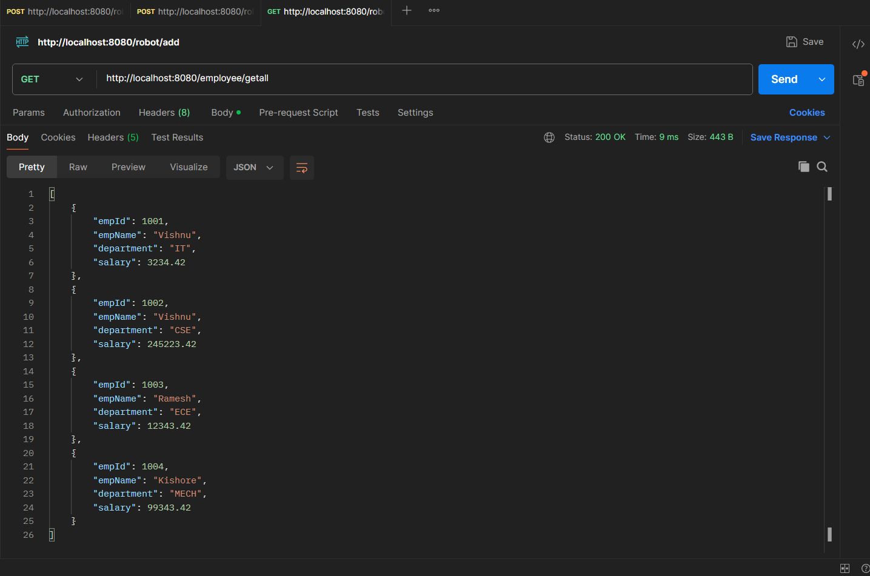

Search by Id using Get Method
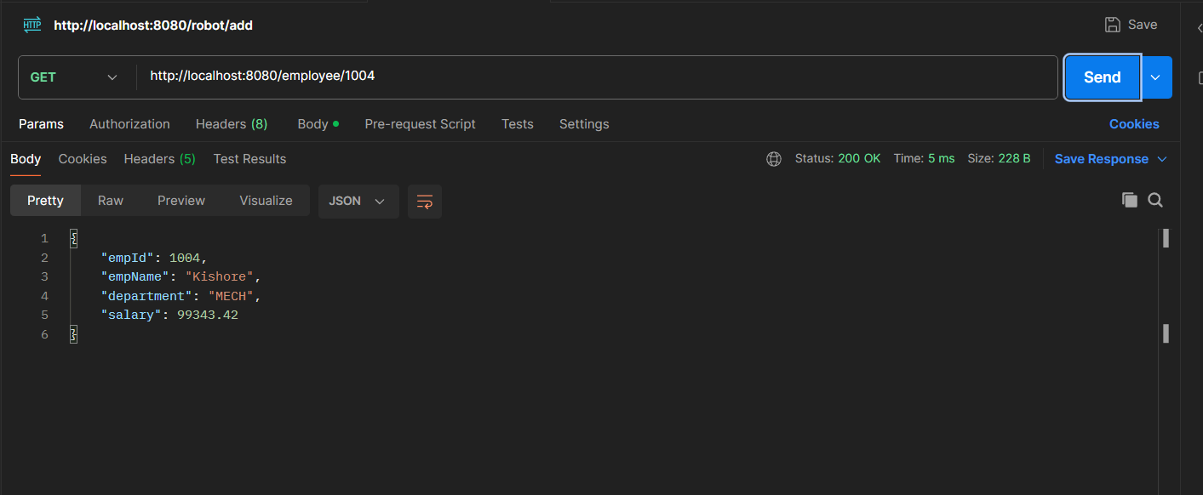

Delete by Id using DELETE method
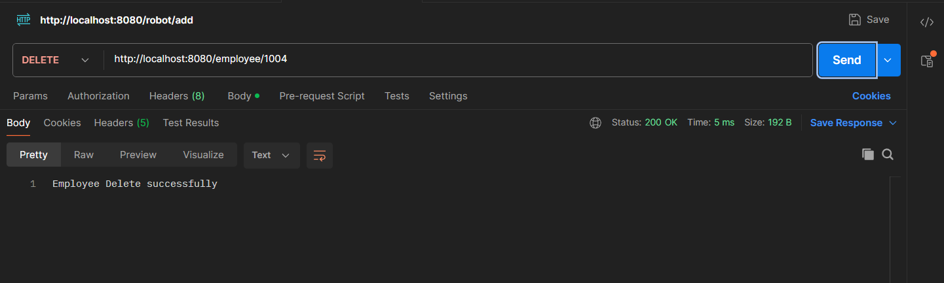

Finaly fetch all employees using GET method
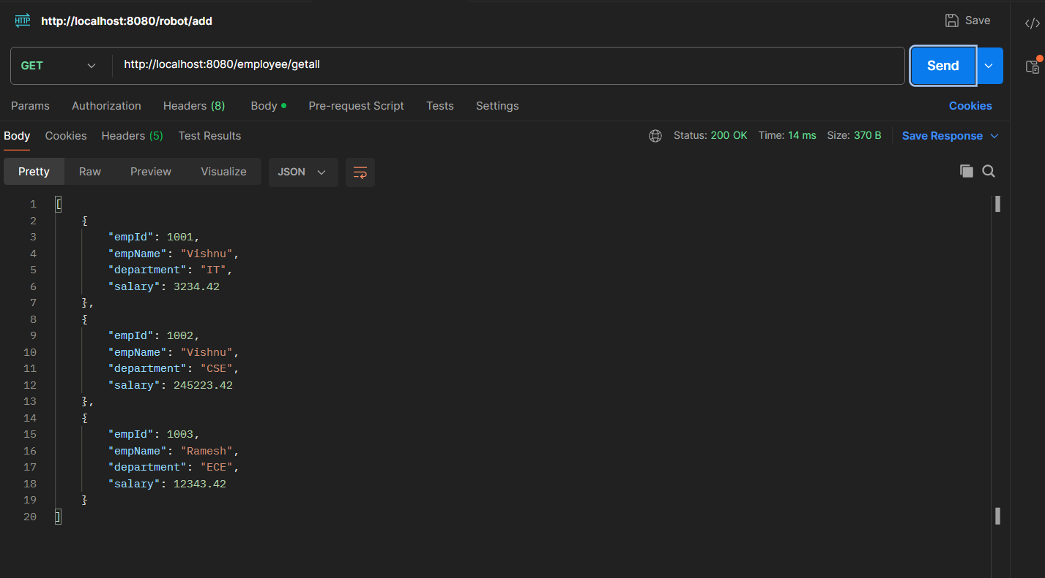

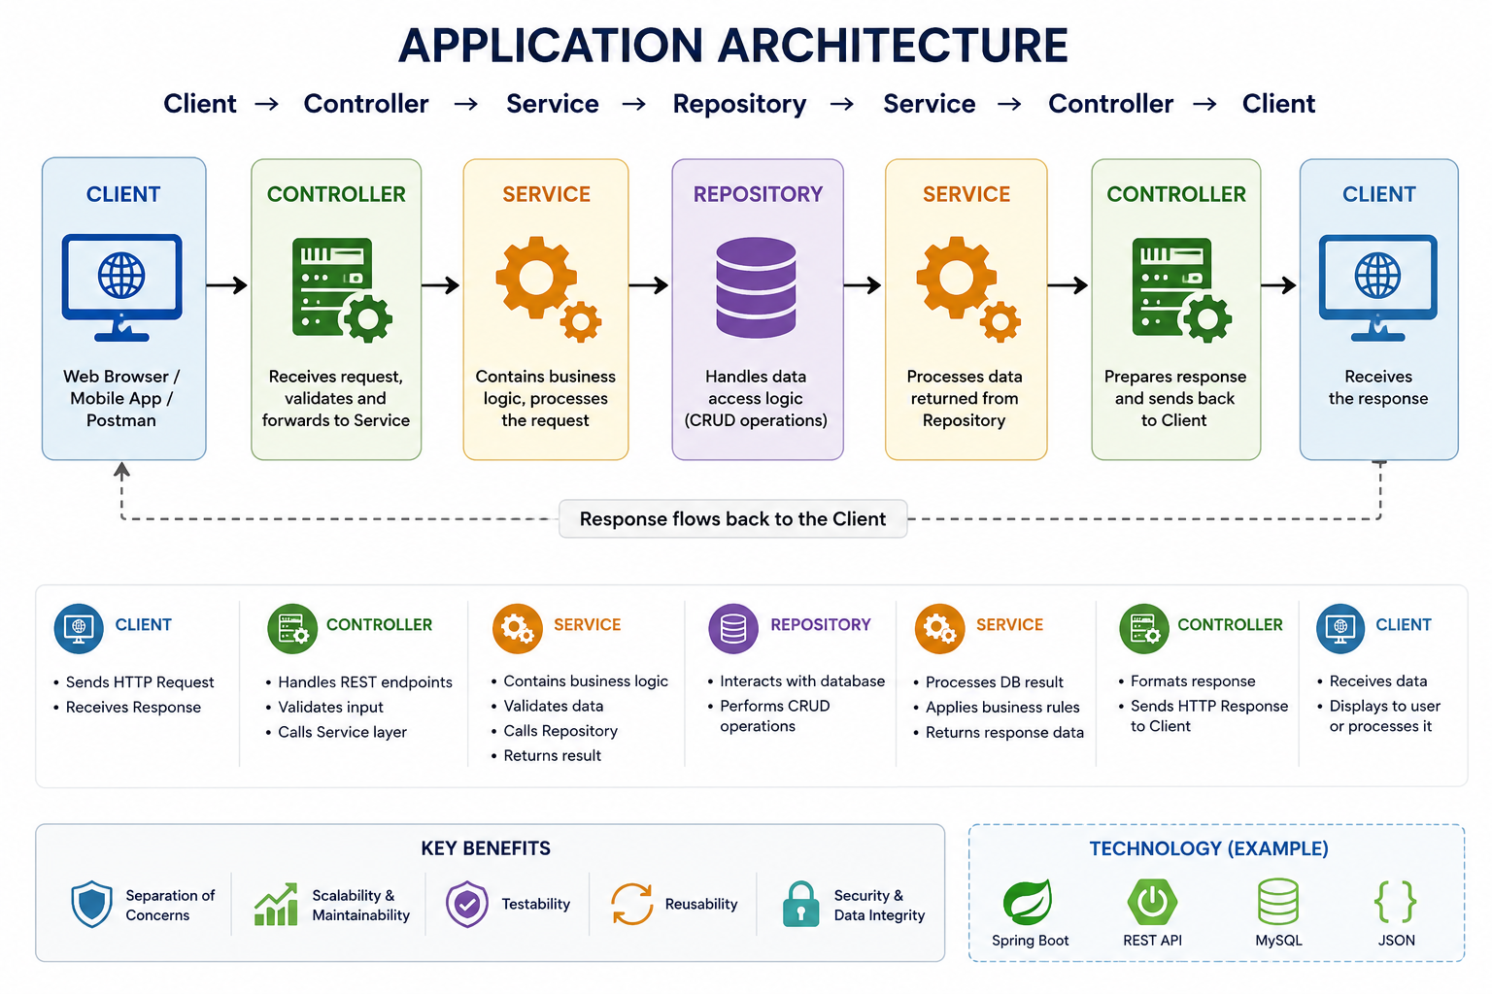
Explain the flow of a request:

The flow explanation:

Client
Client or Browser send request to the controller.

Controller
The responsibilities of the controller now handle request from the client and send to the service layer also converts “json” or anything to java object based on spring annotations.

Service
Service layer handles the controller what ask to process the and send to the repository layer.

Repository
Repository has connected with multiple databases and handles the data store list, database, cloud like so the service what ask process and give back to the service.

Service
Now the service processes the data get from the repository and give back to the Controller.

Controller
Now response from the service the controller send response to the client

Client
Now the client what request sent the controller that will be back to the response.

